**Pakistan suicide bombings from**

**1995-2016**

**Data & Statistics per annum**

**By Aliza Ansari.**

**ABSTRACT**:

In the research we conducted we analysed the strategically crucial period of 1995-2016 for the Islamic republic of Pakistan. The dataset in consideration contains detailed information of 475 suicide bombing attacks in Pakistan that killed an estimated 6,982 and injured 17,624 people. The data mining was done thoroughly from numerous sources including eminent newspapers of Pakistan and international media. The data scrapping was also done by numerous articles published on the website of Pakistan Body Count (www.PakistanBodyCount.org) that is the oldest and most accurate running tally of suicide bombings in Pakistan. By [using fuzzy matching we corrected the inconsistent data entry](https://www.kaggleusercontent.com/kf/3012975/eyJhbGciOiJkaXIiLCJlbmMiOiJBMTI4Q0JDLUhTMjU2In0..PZWnAnc6xkwFLx_B98_vyw.MXPJUTi6fIf53Wj0OxmcXO6WnlF89IBgsYUgxFyBjgmKKtVbMjgSPT1EsE5pSIzsGNEzn_oR_qOc-eeTwfVl4fn1oQ3XsEpG02XPa_gqYEgqrH6XKwLVt38vPRbMb0fQZA-HZCVoaohJjv7AUJASYuOAguM1Jhx-DMxoTVLPHEw.EY9E39o50lDnijLLNIqqmg/__results__.html#Use-fuzzy-matching-to-correct-inconsistent-data-entry) and cleaned the data to display the accurate data by the use of several graphs.

**Suicide bombing in the state of Pakistan:**

Terrorism in Pakistan according to [Ministry of Interior](https://en.wikipedia.org/wiki/Ministry_of_Interior_(Pakistan)), poses a significant threat to the people of Pakistan. The current wave of terrorism is believed to have started in 2000and peaked during 2009. Since then it has drastically declined as result of military operations conducted by the [**Pakistan Army**](https://en.wikipedia.org/wiki/Pakistan_Army)**.**  According to South Asian Terrorism Portal Index (**SATP**), terrorism in Pakistan has declined by **89%** in 2017 since 2009. But these attacks haven’t just started from the 21st century but from the year 1995. Suicide Bombing have significantly been the top on how the land has seen massive loss.

**DAMAGE:**

Suicide Bombing has wreaked havoc in Pakistan in the last decade or so. From only a couple of attacks before 2000, it kept escalating after the US Operation Enduring Freedom in Afghanistan, promiscuously killing hundreds of people each year, towering as one of the most prominent security threats that every single Pakistani faces today. The conundrum of suicide bombing in Pakistan has obliterated 6,982 clean-handed civilians and injured another 17,624 in a total of 475 attacks since 1995. More than 94% of these attacks have taken place after year 2006. From 2007 to 2013 the country witnessed a suicide bombing attack on every 6th day that increased to every 4th day in 2013. Counting the dead and the injured, each attack victimizes 48 people in Pakistan.

**METHODOLOGY:**

**DATA EXTRACTION DETAILS:**

* Geography: Pakistan
* Time period: 1995-2016
* Unit of analysis: Attack
* Dataset: The dataset contains detailed information of 475 suicide bombing attacks in Pakistan that killed an estimated 6,982 and injured 17,624 people.
* Variables: The dataset contains Serial No, Incident Date, Islamic Date (based on Islamic lunar calendar), approximate Time, Long-Lat, City, Province, Location, Location Sensitivity & Type, Target type and Sect, Open/Close Space (as it will change the impact of blast waves due to reflection), min and max number of people killed and injured, number of suicide bombers, amount of explosive being used and the name of hospitals where victims went for treatment.
* Algorithms The handling of the missing values, scaling and normalization of the data parsing dates, character encoding done, inconsistent data entries removed.
* Sources: Unclassified media articles, hospital reports, think tank analysis and reports, and government official press releases.
* The data extracted from <http://www.pakistanbodycount.org/suicide_bombing.php> was in the form of text with links to different newspaper & information sources. The numbers were gathered individually from the most authentic papers like Dawn, Express, Tribune, Samaa, TheStatesMan etc. covering the stories.

**Why the data matters:**Suicide bombing is an operational method in which the very act of the attack is dependent upon the death of the perpetrator. Though only 3% of all terrorist attacks around the world can be classified as suicide bombing attacks these account for 48% of the casualties. Explosions and suicide bombings have become the modus operandi of terrorist organizations throughout the world. The world is full of unwanted explosives, brutal bombings, accidents, and violent conflicts, and there is a need to understand the impact of these explosions on one’s surroundings, the environment, and most importantly on human bodies. From 1980 to 2001 (excluding 9/11/01) the average number of deaths per incident for suicide bombing attacks was 13. This number is far above the average of less than one death per incident across all types of terrorist attacks over the same time period. Suicide bombers, unlike any other device or means of destruction, can think and therefore detonate the charge at an optimal location with perfect timing to cause maximum carnage and destruction. Suicide bombers are adaptive and can quickly change targets if forced by security risk or the availability of better targets. Suicide attacks are relatively inexpensive to fund and technologically primitive, as IEDs can be readily constructed.

**Functions used:**

The **describe()** function computes a summary of statistics pertaining to the DataFrame columns. This function gives the mean, std and IQR values. And, function excludes the character columns and given summary about numeric columns.

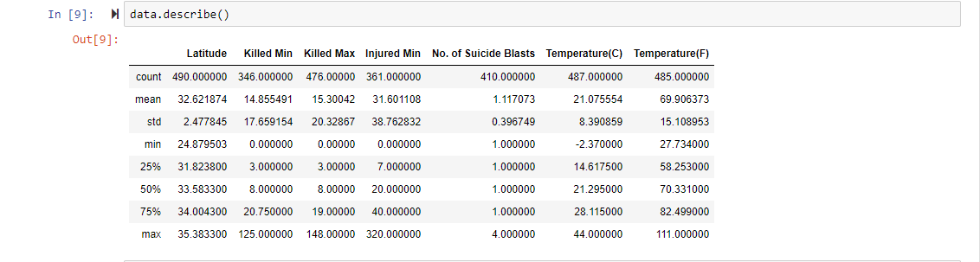

The function **subplot()** create a figure and a set of subplots. It is a wrapper function to make it convenient to create common layouts of subplots, including the enclosing figure object, in a single call.

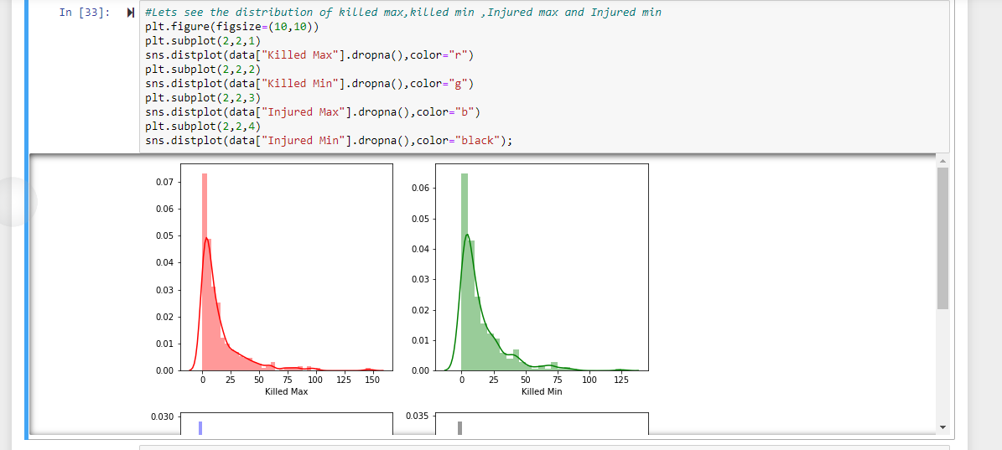

A histogram is an accurate graphical representation of the distribution of numerical data. It is an estimate of the probability distribution of a continuous variable (quantitative variable). For plotting a histogram we use **hist()** function.

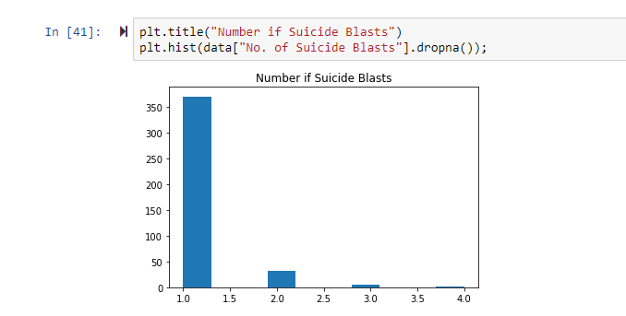

Several other functions are used to summarize and show the effect of the data figures.  
  
Below is the.

Below is a link to the cleaned data that has been plotted on bar graphs, dotted graphs, line graphs using data mining technique and various other algorithms, representing the exact places, communities and events that were targeted in the suicide attacks executed from 1995 till 2016 in Pakistan by various terrorist organizations.

[Complete data for suicide bomb attacks](../Downloads/Pakistan-Suicide-Bomb-Attacks%20(1).html)

**Acknowledgements & References:**

Pakistan Body Count has been leveraged extensively in scholarly publications, reports, media articles and books. The dataset has been curated by Aliza Ansari.

The website and data set was collected formally from Zeeshan-ul-hassan Usmani, Pakistan Body Count, Pakistan Suicide Bombing Attacks Dataset, Kaggle Dataset Repository, Jan 25, 2017.